1. **Adding a new Product**

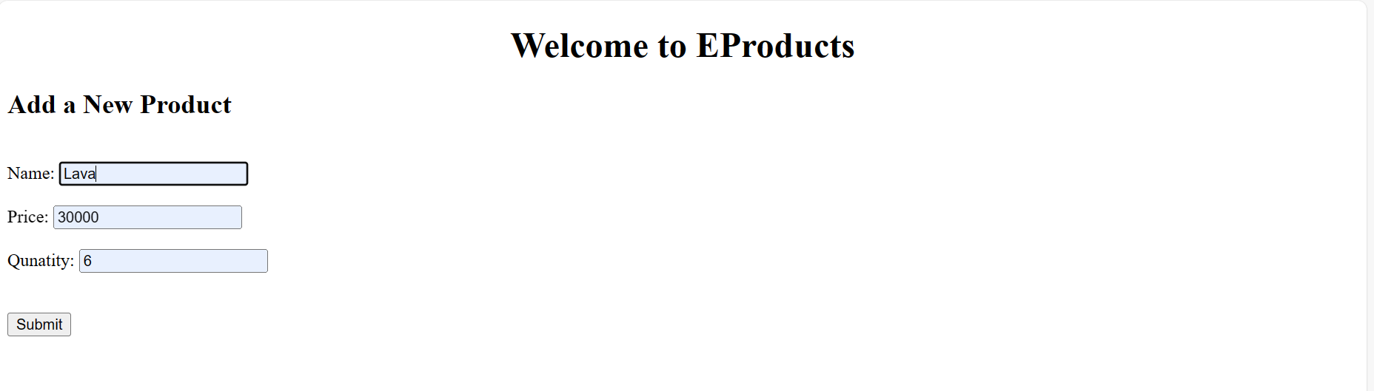

1. **Seeing the data in a portal**

